Question 1. Capture an unstructured light field (3 points)

Answer:

I tried circle and zig-zag motion and different distance to record videos.

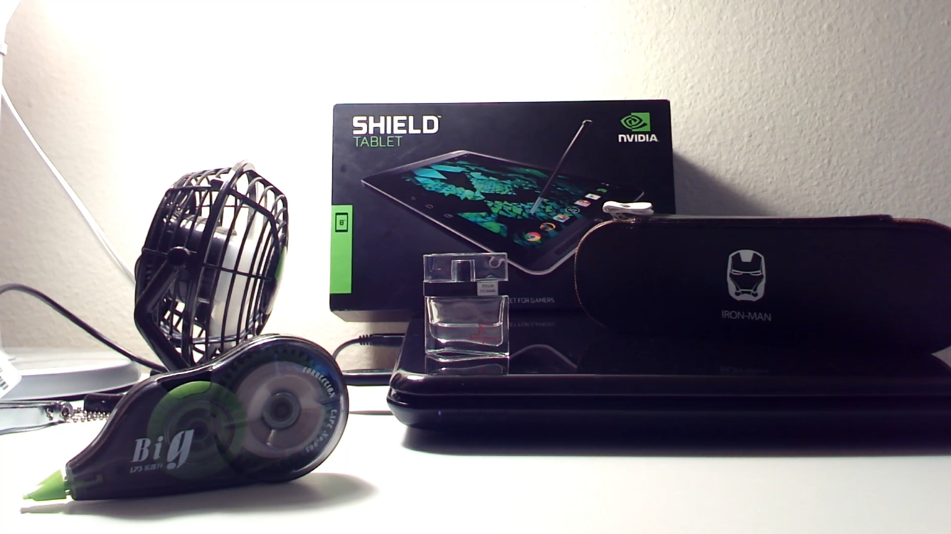

Figure 1. Circle motion

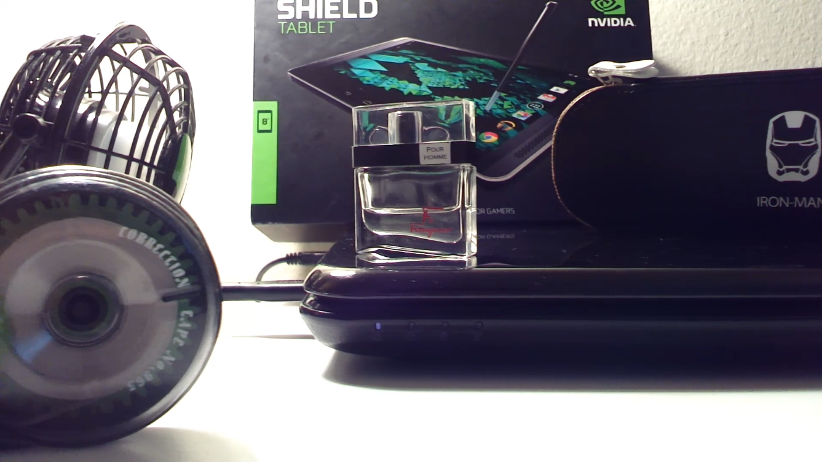

Figure 2. Zig-zag motion

Question 2. Register the frames of video using template matching (5 points)

Answer:

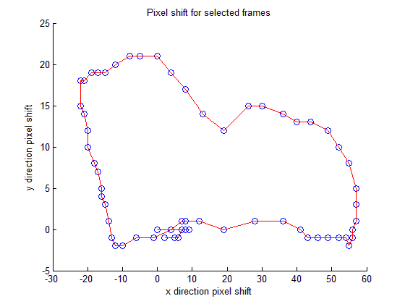

Figure 3. Circle motion

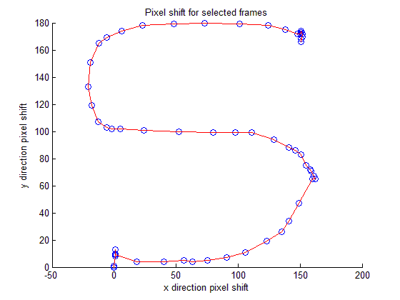

Figure 4. Zig-zag motion

Matlab Codes

%%%%%%Circle motion%%%%%%

clc;

clear;

close all;

video=VideoReader('D:\Courses Files_2015_Fall\Introduction to Computational Photography\HW6\VID_20151129_140828.mp4');

number=video.NumberOfFrames;

n=round(number/5-0.5);

x=zeros(n,1);

y=zeros(n,1);

Frames=cell(n,1);

for i=1:n

Frames{i}=im2double(rgb2gray(read(video,1+(i-1)*5)));

end

template1=imcrop(Frames{1});

A=normxcorr2(template1,Frames{1});

[a,b]=find(A==max(max(A)));

for i=2:n

A=normxcorr2(template1,Frames{i});

[x(i),y(i)]=find(A==max(max(A)));

x(i)=x(i)-a;

y(i)=y(i)-b;

end

scatter(y,x,'o');

hold on

plot(y,x,'red');

title('Pixel shift for selected frames');

xlabel('x direction pixel shift');

ylabel('y direction pixel shift');

%%%%%%Zig-zag motion%%%%%%

clc;

clear;

close all;

video=VideoReader('D:\Courses Files_2015_Fall\Introduction to Computational Photography\HW6\VID_20151129_141450.mp4');

number=video.NumberOfFrames;

n=round(number/5-0.5);

x=zeros(n,1);

y=zeros(n,1);

% n=40;

Frames=cell(n,1);

for i=1:n

Frames{i}=im2double(rgb2gray(read(video,1+(i-1)*5)));

end

% imshow(Frames{1});

template1=imcrop(Frames{1});

A=normxcorr2(template1,Frames{1});

[a,b]=find(A==max(max(A)));

for i=2:n

A=normxcorr2(template1,Frames{i});

[x(i),y(i)]=find(A==max(max(A)));

x(i)=x(i)-a;

y(i)=y(i)-b;

end

scatter(y,x,'o');

hold on

plot(y,x,'red');

title('Pixel shift for selected frames');

xlabel('x direction pixel shift');

ylabel('y direction pixel shift');

Question 3&4. Create a synthetic aperture photograph (5 points) and Refocus on a new object (2 points)

Answer:

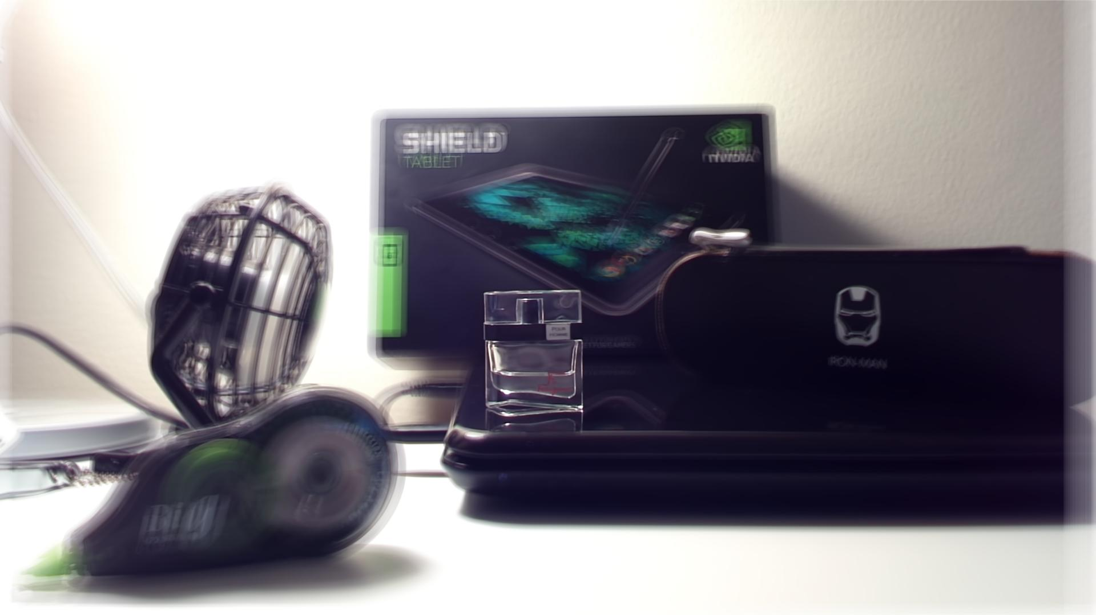

Figure 5. focus on the perfume(circle)

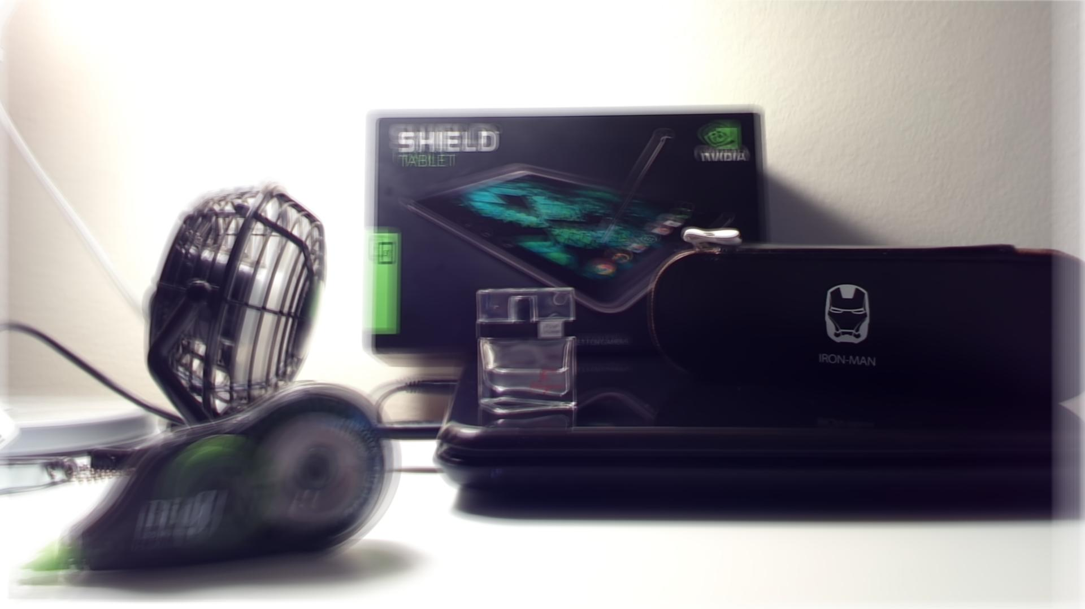

Figure 6. focus on the pen bag(circle)

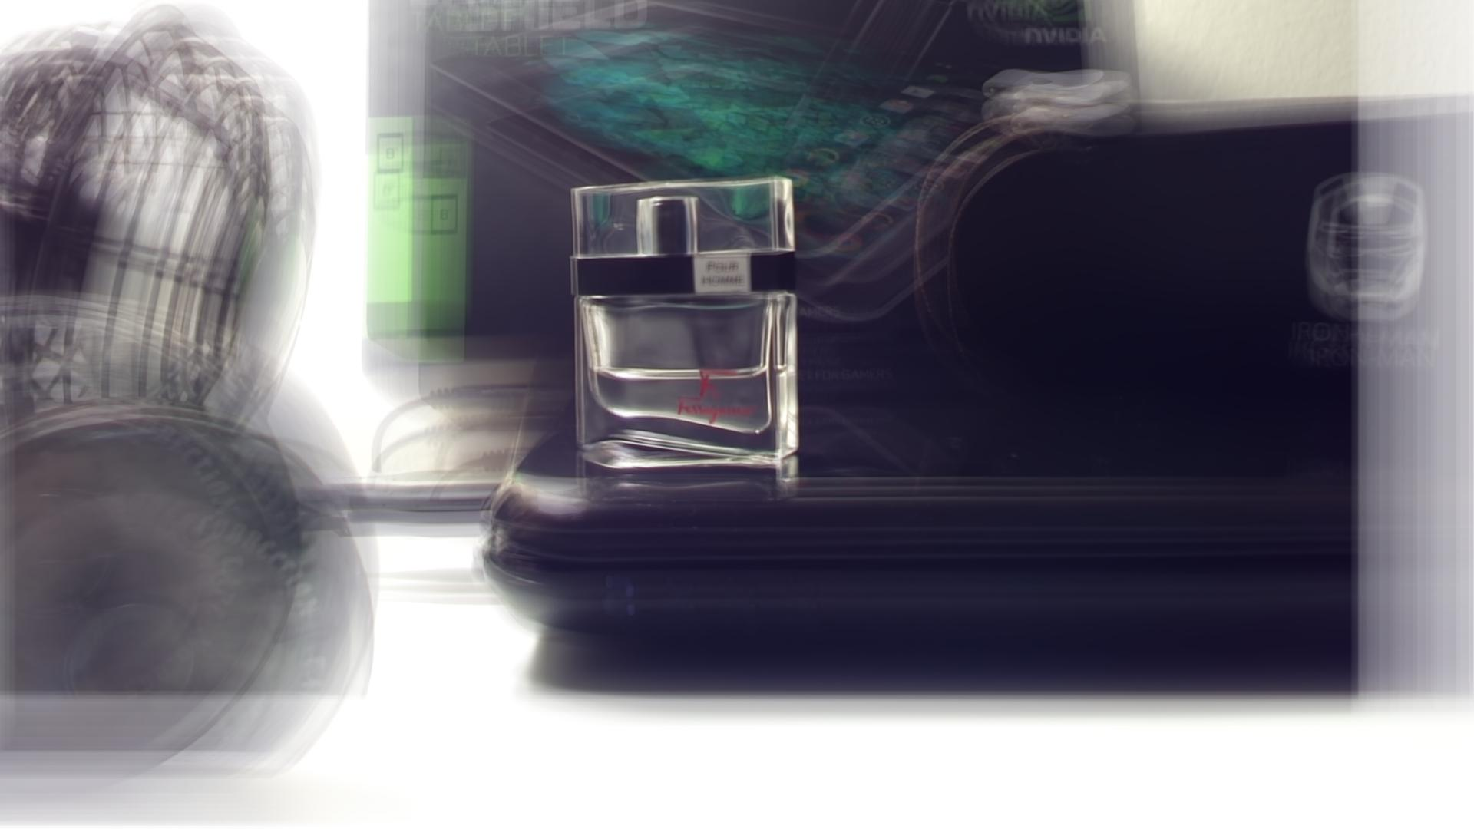

Figure 7. focus on the perfume(zig-zag)

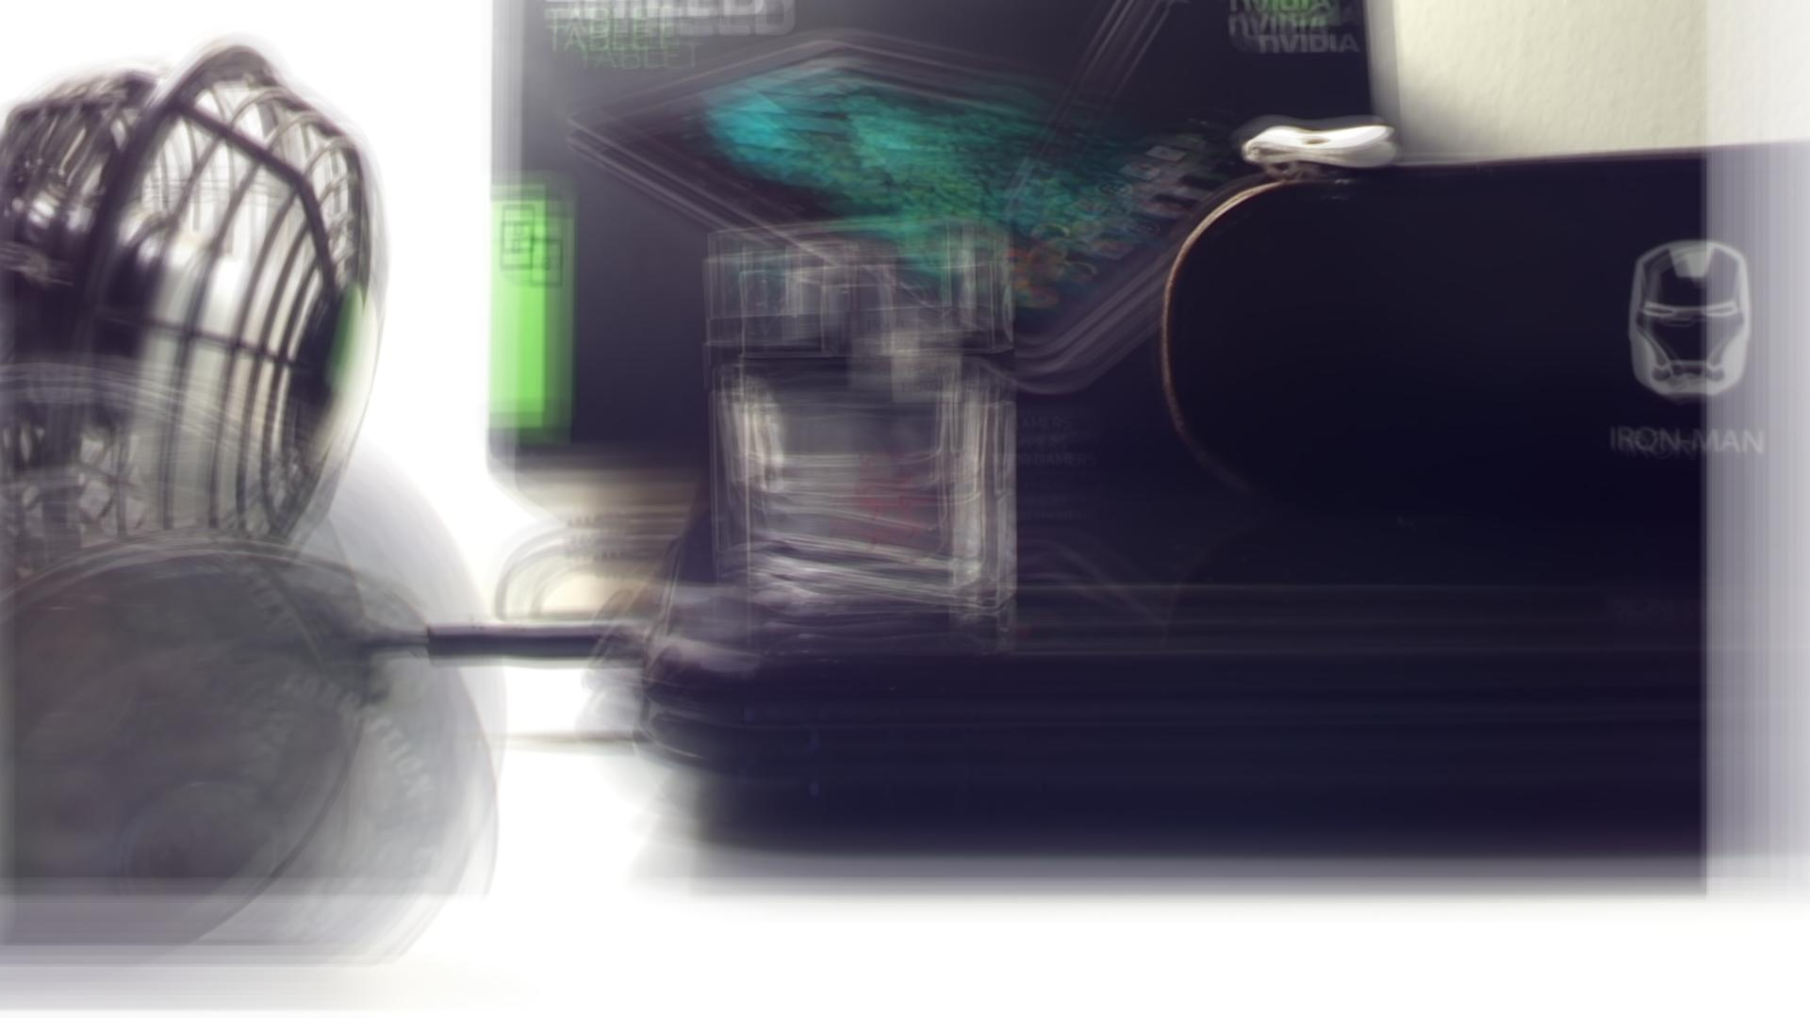

Figure 8. focus on the pen bag(zig-zag)

Matlab Codes

final=zeros(1080,1920,3);

for i=1:n

final=final+imtranslate(im2double(read(video,1+(i-1)*5)),[-y(i),-x(i)],'Fillvalues',1);

end

final=final./n;

imshow(final);

imwrite(final,'2.jpg','jpeg')